Walmart Sale
Report
Tien V Nguyen
Table of Contents
Contents
1. Abbreviations 1
2. Background and Motivation: 2
3. Data 2
4. Models 3
5. Results 3
6. Implications 4
7. Limitations 5
8. Sources 5
9. AI Declaration. 5
10. Technical Appendix 5

Abbreviations

Store | The store number
Date | The week of the sale in day-month-year format.
Weekly_Sales | The sales for the given store in the given week.
Holiday_Flag | Whether the week is a special holiday week (1) or not
Temperature | The average temperature in the region (in Fahrenheit)
Fuel_Price | The cost of fuel in the region (in dollars per gallon)
CPI | The consumer price index
Unemployment: | The unemployment rate in the region

Table 1: Data terminology explanation.

Background and Motivation
Understanding the impact of temperature variation on Walmart’s weekly sales is an important empirical question. To investigate this relationship, data were collected from 45 Walmart stores covering the period from February 2010 through October 2012.

In addition to weekly sales and average temperature, several other variables were included to better control for external factors that may influence sales. These variables include the regional unemployment rate, the consumer price index (CPI), the week of sales (recorded in dd-mm-yyyy format), and the store identification number.

Data
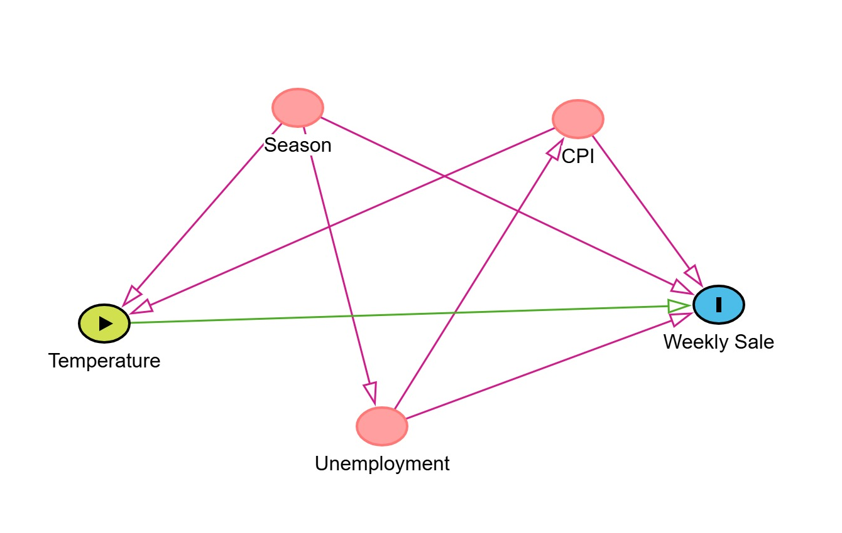
The dataset consists of weekly sales from 45 Walmart stores spanning February 2010 through October 2012, totaling 6,435 observations.
Figure 1: Model visualization.

Based on the collection dates, the data were grouped by season. According to U.S. meteorological classifications, January to March is defined as Winter, April to June as Spring, July to September as Summer, and October to December as Fall.

Seasonality was expected to influence both holiday frequency and unemployment. Since different seasons contain varying numbers of holidays that may affect sales patterns, the Holiday variable was excluded under the assumption that seasonal indicators could capture its effect. Although unemployment may fluctuate across seasons ⁽¹⁾, particularly during spring and summer hiring periods, it was retained in the model because it is expected to have independent effects on sales and broader economic conditions, including its association with CPI.

Fuel Price was also excluded due to its strong positive relationship with the Consumer Price Index (CPI) ^{(2).} As higher inflation is typically associated with increased fuel prices, including CPI in the model may sufficiently capture the variation explained by fuel prices, thereby reducing concerns of multicollinearity.

The relationships among the variables were structured under the following assumptions. CPI may influence weekly sales through its impact on consumer purchasing power, as higher inflation can alter household spending behavior, including grocery expenditures. CPI is also closely related to fuel prices. Increases in fuel prices, whether driven by market conditions or energy-related policies, may reduce fuel consumption and transportation activity. In the long run, reduced fuel consumption could contribute to lower greenhouse gas emissions, which are associated with temperature patterns. While this channel is likely to operate gradually rather than immediately, it provides a theoretical basis for considering the indirect linkage between fuel prices, broader economic conditions, and temperature variation.

Additionally, seasonal factors directly affect temperature and labor market conditions, influencing unemployment rates. Higher unemployment may reduce aggregate consumer spending, thereby lowering weekly sales.

Lastly, the correlation matrix was run between all the chosen variables to make sure there is no bias between all the independent variables (Table 3)

Models
This report estimates two regression models. In model 1, controlling for/ without including other variables, within a store, the pooled relationship between temperature and weekly sales was examined, since there was a wonder on direct relationship between temperature effected on weekly sales, without the involving of other characteristics. Multiple plots have been applied to temperature and weekly sales to find out which model would best fit temperature and weekly sale. (Plot , log on X, log on Y, polynomial)
On the other hand, Model 2 estimates how changes in temperature, CPI, unemployment, and seasonal factors over time affect weekly sales. Also, standard errors are clustered at the store level to account for potential correlation of observations within each store. (Plot, |Store, vcov=~store))

Results (Re-run foels models)

Parameter | Model 1 | Model 2 (Within- demeaned)
Dependent Variable | Weekly Sale
Constant | 1,165,406.0*** (24,139.0) | 61,427.2*** (6,856.7)
Temperature | -1,952.4*** (380.7) | -2,259.2*** (373.0)
Season - Spring |  | -55,385.5*** (7,027.0)
Season - Summer |  | -48,858.9*** (5,931.1)
Season - Winter |  | -141,506.1*** (16,674.6)
CPI |  | -662.9 (2,359.3)
Unemployment |  | -18,477.8 (11,810.7)
S.E type | IID | By: Store
R² | 0.00407 | 0.09256
Adjusted R² | 0.00392 | 0.09171
Observation | 6435
Signif. codes: 0 '***' 0.001 '**' 0.01 '*' 0.05 '.' 0.1 ' ' 1
Table 2: Regression Model Result

Implications
The results from both models consistently indicate that higher temperatures are associated with lower weekly sales across the 6,435 observations.
In Model 1, which estimates a pooled regression, a one-unit increase in temperature is associated with an average decrease of $1,952 in weekly sales, holding other factors constant. This relationship is statistically significant at the 1% level.
In Model 2, which controls for store fixed effects and other covariates, the negative relationship remains. Within a store, a one-unit increase in temperature is associated with a larger decrease of $2,259 in weekly sales. This suggests that even after controlling for seasonal factors, CPI, unemployment, and store-specific characteristics, temperature continues to have a significant negative effect on sales.
Seasonal indicators also show significant differences relative to the omitted category (Fall). Within a store, average weekly sales are lower by roughly $55,386 in Spring, $48,859 in Summer, and $141,506 in Winter compared to Fall. This relationship is statistically significant at the 1% level.
CPI and unemployment both have negative estimated coefficients in Model 2; however, neither coefficient is statistically significant at conventional levels. This suggests that while the estimated direction aligns with theoretical expectations, there is insufficient statistical evidence to confirm their independent effects on weekly sales in this specification.
Overall, the findings support the hypothesis that temperature negatively affects weekly sales. As temperature increases, weekly sales decline, and this result remains robust after controlling for store-level fixed effects and other economic variables.

Limitations
The survey covers only a two-year period and includes a limited number of explanatory variables. Important factors such as store size, local weather conditions, and population characteristics were not available, which may limit the explanatory power of the model.

Sources
- Fiveable. (2024, July 31). Seasonal Unemployment – AP Macroeconomics. https://fiveable.me/key-terms/ap-macro/seasonal-unemployment.
- Kpodar, K., & Liu, B. (2022). The distributional implications of the impact of fuel price increases on inflation. Energy Economics, 108, 105909. https://doi.org/10.1016/j.eneco.2022.105909

AI Declaration
ChatGPT assisted but not others with refining the written content and troubleshooting coding errors encountered during the analysis.

Technical Appendix

 | Weekly Sales | Temperature | CPI | Unemployment
Weekly Sales | 1.00 | -0.06 | -0.07 | -0.11
Temperature | -0.06 | 1.00 | 0.18 | 0.10
CPI | -0.07 | 0.18 | 1.00 | -0.30
Unemployment | -0.11 | 0.10 | -0.30 | 1.00

Table 3: Correlation Matrix:

Model 1. R output

Model 2. Output

